Perform Health Checks and Remedy Issues

Step 1: Conduct a health check on your test environment:

Incident:

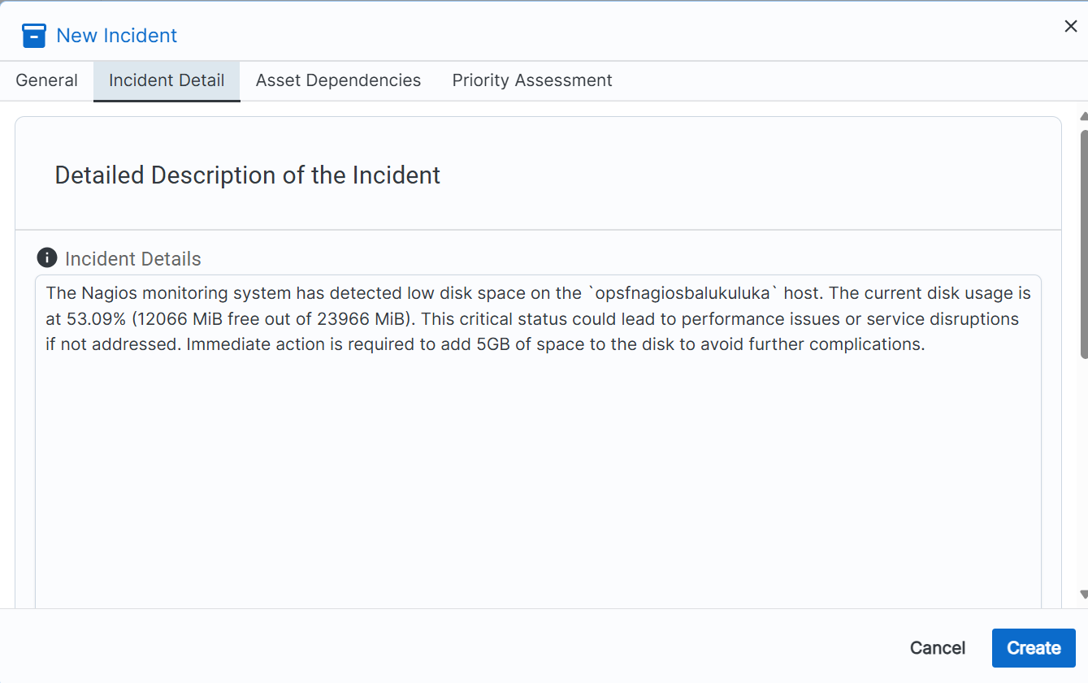

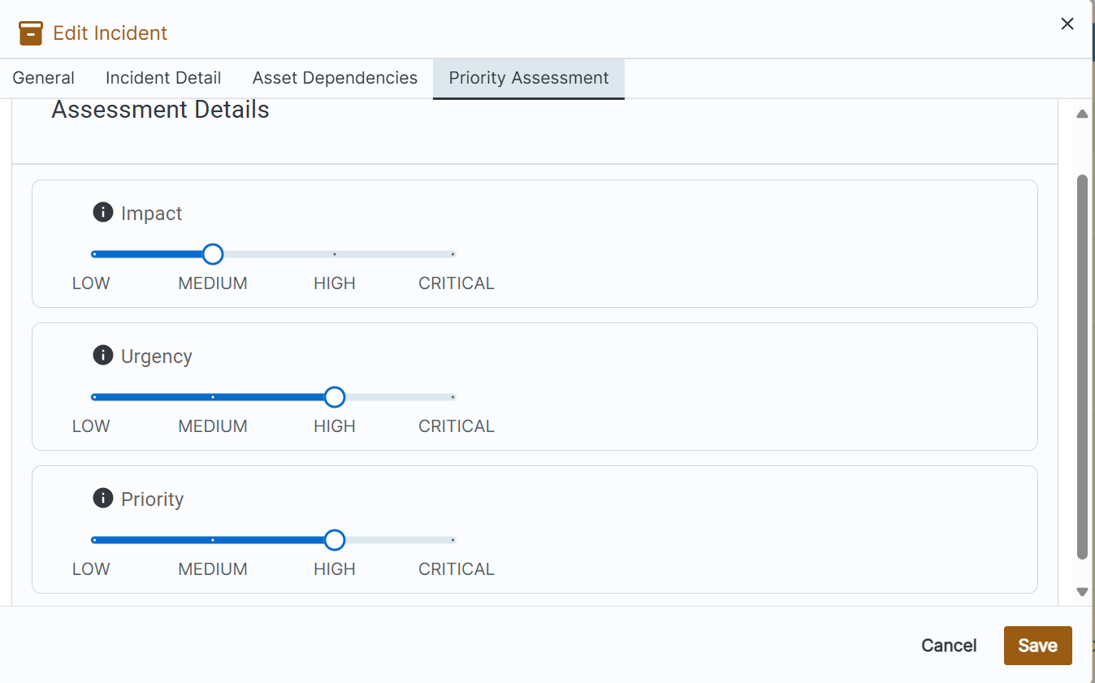

Change Request:

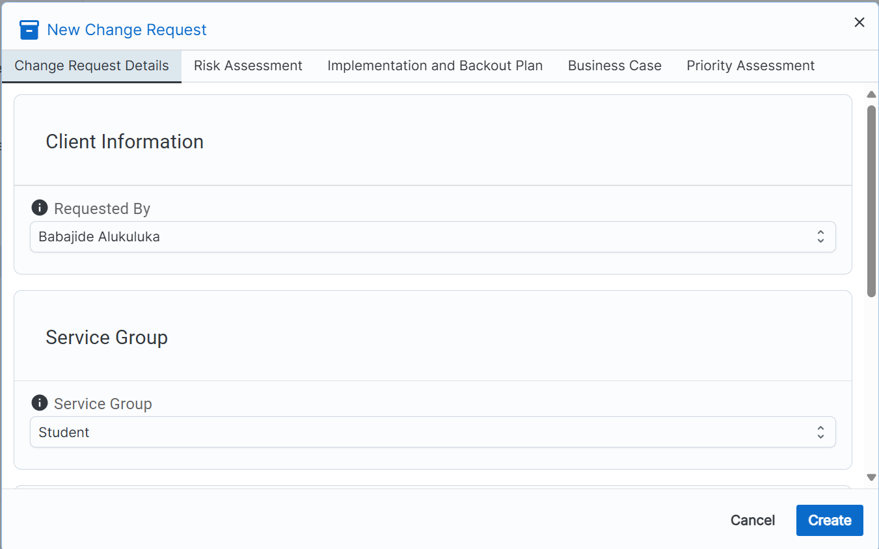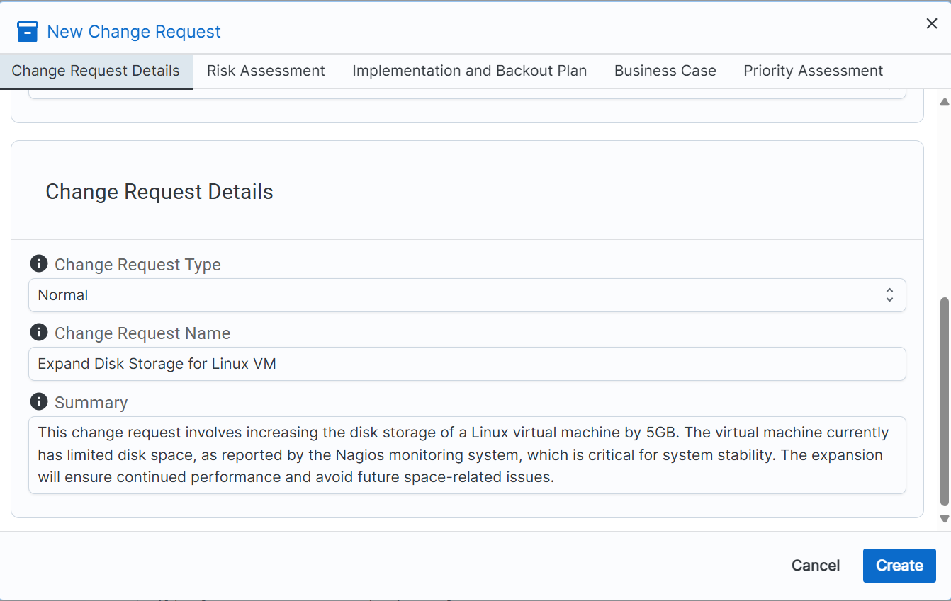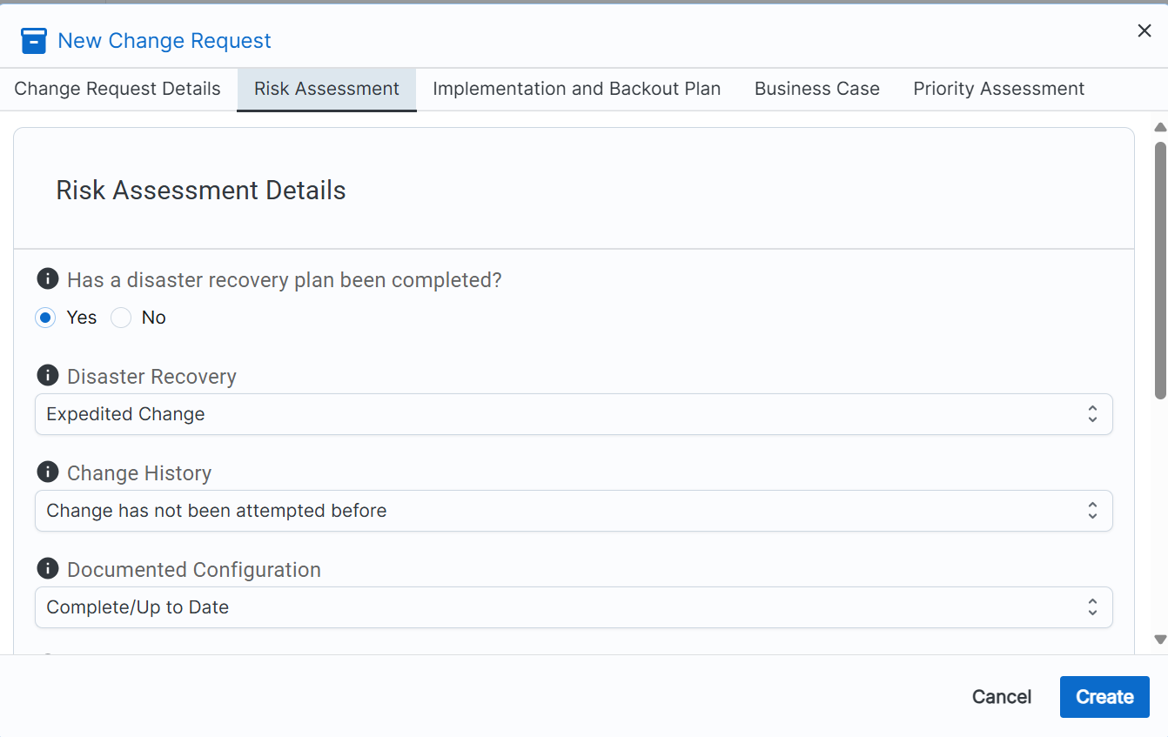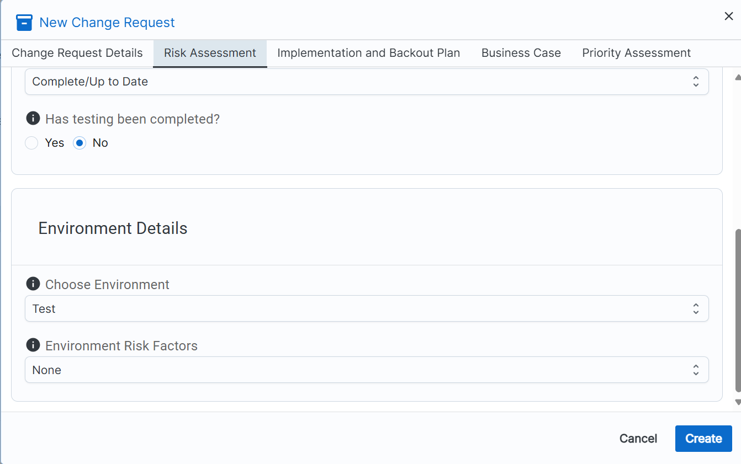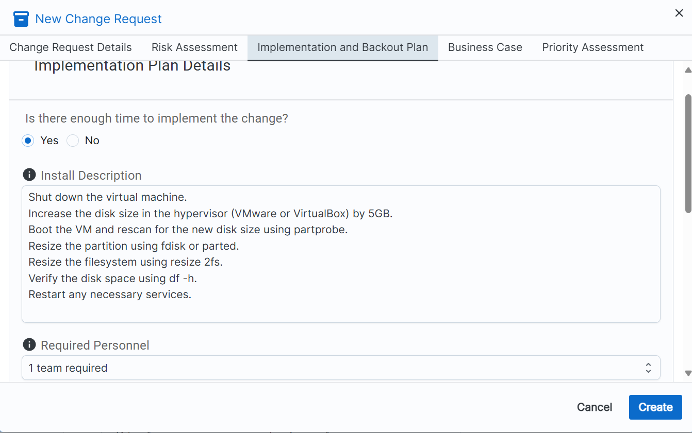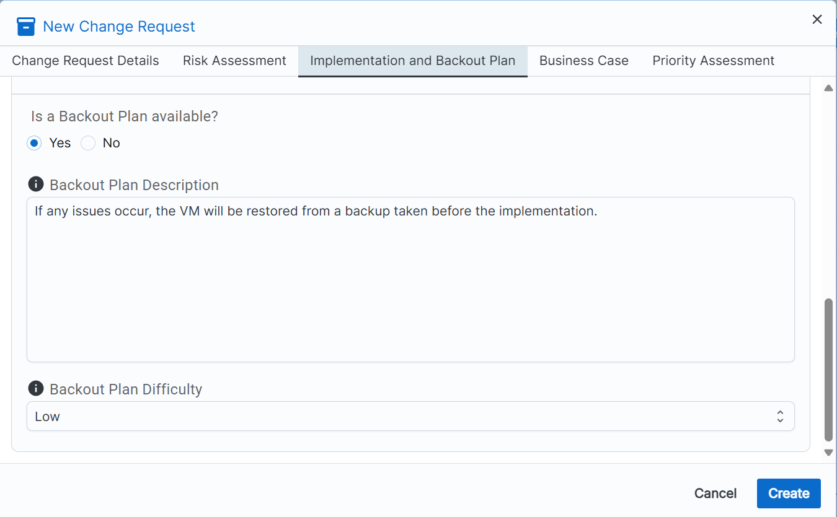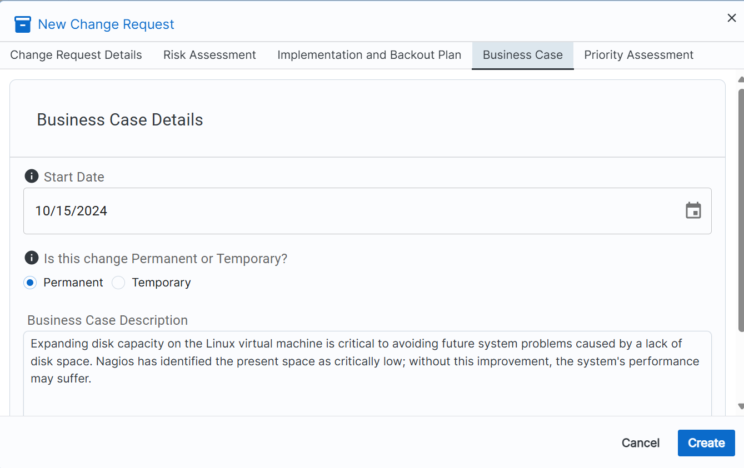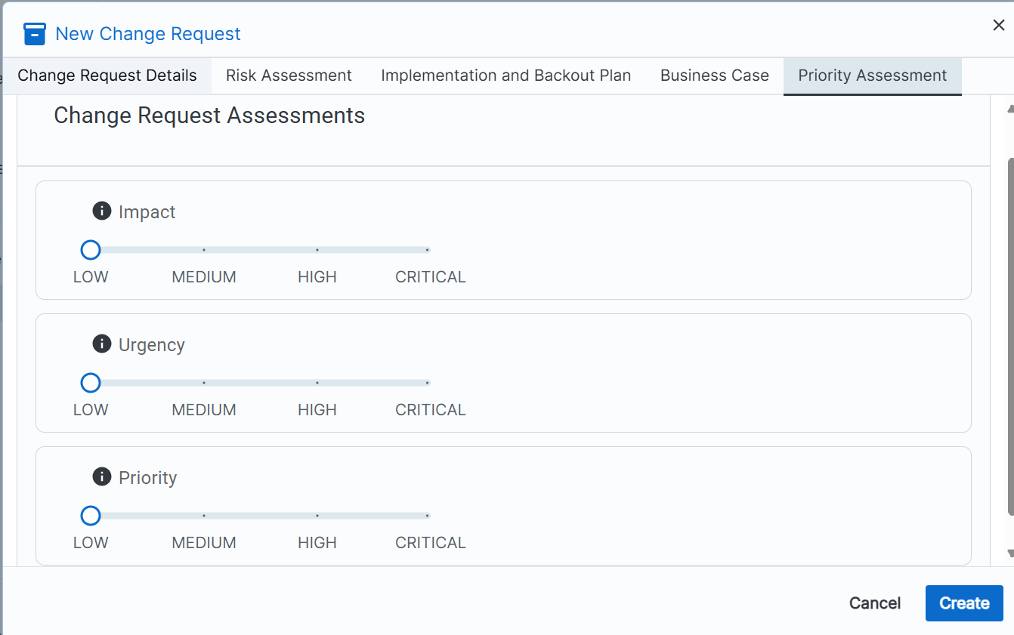

[How to Increase Size of Disk Partition in Ubuntu | Windows OS Hub (woshub.com)](https://woshub.com/increase-partition-size-ubuntu/)

[How to Resize Partitions in Ubuntu (fleetstack.io)](https://fleetstack.io/blog/ubuntu-resize-partition-guide)

**Health Check Report - Nagios Monitoring**

**To:** IT Operations Supervisor  
**From:** Babajide Alukuluka  
**Date:** October 14, 2024  
**Subject:** Health Check Results and Remediation Actions

**1. Overview:**

A scheduled health check was conducted on **October 14, 2024, at 8:40 PM CDT** using the Nagios monitoring system. The purpose of this check was to assess the health of all critical hosts and services under surveillance. The results and any required remediation actions are summarized below.

**2. Health Check Results:**

The following services and hosts were checked, and the results are detailed here:

* **Host: localhost**
  + **Root Partition:** **CRITICAL** – Disk space critically low. Only **53.09% free** (12 GB out of 22 GB available).
  + **SSH Service:** **CRITICAL** – SSH service down. "Connection refused" on port 22.
* **Host: opsfnagiosbalukuluka**
  + **Hard Disk:** **CRITICAL** – Disk space critically low. **53.09% free**.
  + **Memory Usage:** **OK** – 66% of memory available.
  + **Web Checks (HTTP):** **OK** – Response time within acceptable limits.

**3. Remediation Actions:**

* **Disk Space Remediation on localhost and opsfnagiosbalukuluka:**
  + I performed an expansion of the virtual machine disk space by adding 5GB to both localhost and opsfnagiosbalukuluka. This increase was implemented following a proper change request process.
  + **Result:** Disk utilization is now within acceptable levels. The updated space available is 17 GB out of 27 GB after expansion.
* **SSH Issue on localhost:**
  + **Action Taken:** I restarted the SSH service, and it is now operating normally.
  + **Verification:** SSH is now accessible on port 22.
* **Root Partition Misconfiguration on balukulukaposf:**
  + I reviewed and corrected the misconfiguration in the Nagios monitoring configuration file, replacing the erroneous argument.
  + **Result:** The root partition will now report correctly in future checks.

**4. Summary of Findings:**

* The most critical issue, low disk space on both localhost and opsfnagiosbalukuluka, has been resolved through a disk expansion. The SSH issue on localhost has also been remediated.
* Misconfigured root partition check on balukulukaposf was fixed.

**5. Next Steps:**

* Continue monitoring the disk space on all hosts to prevent future critical incidents.

**Best regards,**  
Babajide Alukuluka  
IT Operations Team  
PiXELL-River Financial

